Introducing Galaxy…

A Career Awareness Platform for Students!

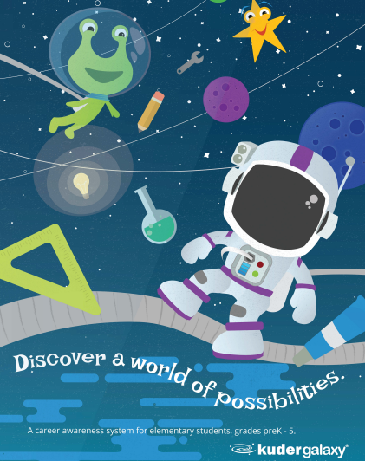

Pinellas County Schools has selected **Galaxy** to provide education and career planning for students in grades Prek-5. Your child has access to Kuder Galaxy® through Clever. Galaxy utilizes the power of play through an interactive space-themed, online platform that allows students to learn through videos, games, activities, and rewards.

Rooted in career development theory and grade-specific career readiness themes, the system lets students at each grade level step foot on six planets — each representing a different work environment: Realistic (the doers), Investigative (the thinkers), Artistic (the creators), Social (the helpers), Enterprising (the persuaders), and Conventional (the organizers). Galaxy also introduces students to 120 careers that help students think beyond their neighborhood.

Galaxy helps broaden young learners’ job vocabulary as it expands their view of their future. Galaxy enables students to uncover their individual interests, develop a sense of self, use relevant information to explore different careers, learn how what they're doing in school connects to what they could do later in life, and complete activities linked to developmentally- and age-appropriate concepts.

**Students can access Galaxy through Clever at school and at home!** Go to Clever, search for the app, and click to begin exploring. Families are supported by Galaxy as well. Parents and guardians can easily access Galaxy’s free parent guide here: <https://galaxy.kuder.com/parents>.